# Examining the Details and Delete Methods

## Examining the Details and Delete Methods

Open the Movie controller and examine the Details method.

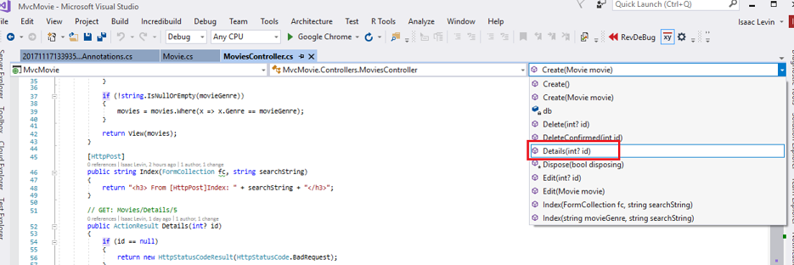

C#

public ActionResult Details(int? id)

{

if (id == null)

{

return new HttpStatusCodeResult(HttpStatusCode.BadRequest);

}

Movie movie = db.Movies.Find(id);

if (movie == null)

{

return HttpNotFound();

}

return View(movie);

}

The MVC scaffolding engine that created this action method adds a comment showing a HTTP request that invokes the method. In this case it's a GET request with three URL segments, the Movies controller, the Details method and a ID value.

Code First makes it easy to search for data using the Find method. An important security feature built into the method is that the code verifies that the Find method has found a movie before the code tries to do anything with it. For example, a hacker could introduce errors into the site by changing the URL created by the links from http://localhost:xxxx/Movies/Details/1 to something like http://localhost:xxxx/Movies/Details/12345 (or some other value that doesn't represent an actual movie). If you did not check for a null movie, a null movie would result in a database error.

Examine the Delete and DeleteConfirmed methods.

C#

// GET: /Movies/Delete/5

public ActionResult Delete(int? id)

{

if (id == null)

{

return new HttpStatusCodeResult(HttpStatusCode.BadRequest);

}

Movie movie = db.Movies.Find(id);

if (movie == null)

{

return HttpNotFound();

}

return View(movie);

}

// POST: /Movies/Delete/5

[HttpPost, ActionName("Delete")]

[ValidateAntiForgeryToken]

public ActionResult DeleteConfirmed(int id)

{

Movie movie = db.Movies.Find(id);

db.Movies.Remove(movie);

db.SaveChanges();

return RedirectToAction("Index");

}

Note that the HTTP Get``Delete method doesn't delete the specified movie, it returns a view of the movie where you can submit (HttpPost) the deletion.. Performing a delete operation in response to a GET request (or for that matter, performing an edit operation, create operation, or any other operation that changes data) opens up a security hole. For more information about this, see Stephen Walther's blog entry [ASP.NET MVC Tip #46 — Don't use Delete Links because they create Security Holes](http://stephenwalther.com/blog/archive/2009/01/21/asp.net-mvc-tip-46-ndash-donrsquot-use-delete-links-because.aspx).

The HttpPost method that deletes the data is named DeleteConfirmed to give the HTTP POST method a unique signature or name. The two method signatures are shown below:

C#

// GET: /Movies/Delete/5

public ActionResult Delete(int? id)

//

// POST: /Movies/Delete/5

[HttpPost, ActionName("Delete")]

public ActionResult DeleteConfirmed(int id)

The common language runtime (CLR) requires overloaded methods to have a unique parameter signature (same method name but different list of parameters). However, here you need two Delete methods -- one for GET and one for POST -- that both have the same parameter signature. (They both need to accept a single integer as a parameter.)

To sort this out, you can do a couple of things. One is to give the methods different names. That's what the scaffolding mechanism did in the preceding example. However, this introduces a small problem: ASP.NET maps segments of a URL to action methods by name, and if you rename a method, routing normally wouldn't be able to find that method. The solution is what you see in the example, which is to add the ActionName("Delete") attribute to the DeleteConfirmed method. This effectively performs mapping for the routing system so that a URL that includes /Delete/ for a POST request will find the DeleteConfirmed method.

Another common way to avoid a problem with methods that have identical names and signatures is to artificially change the signature of the POST method to include an unused parameter. For example, some developers add a parameter type FormCollection that is passed to the POST method, and then simply don't use the parameter:

C#

public ActionResult Delete(FormCollection fcNotUsed, int id = 0)

{

Movie movie = db.Movies.Find(id);

if (movie == null)

{

return HttpNotFound();

}

db.Movies.Remove(movie);

db.SaveChanges();

return RedirectToAction("Index");

}

## Summary

You now have a complete ASP.NET MVC application that stores data in a local DB database. You can create, read, update, delete, and search for movies.

